8 BIT SUBTRACTION

EXPNO:2

AIM: To write an assembly language program to implement 8 bit subtraction using 8085 processor

ALGORITHM:

1. Start the program by loading the first data into the accumulator.
2. Move the data to a register.
3. Get the second data and load it into the accumulator.
4. Add the two register contents.
5. Check for carry.
6. Store the value of sum and carry in the memory location.
7. Halt

PROGRAM:

LDA 8000

MOV B,A

LDA 8001

SUB B

STA 8002

RST 1

INPUT:

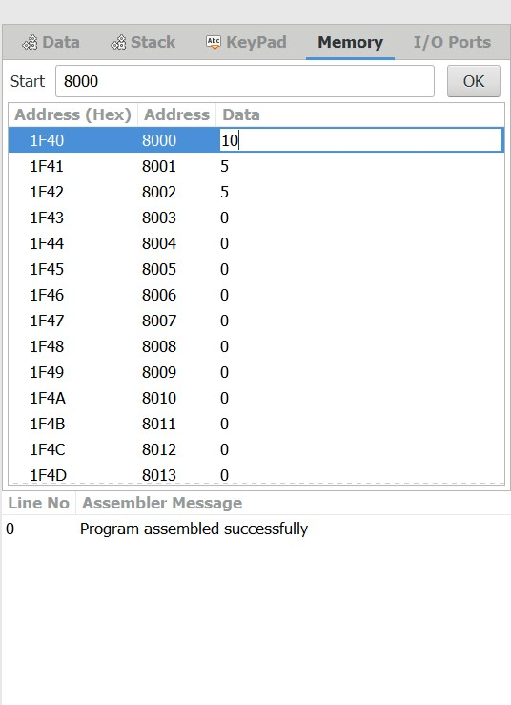

OUTPUT: 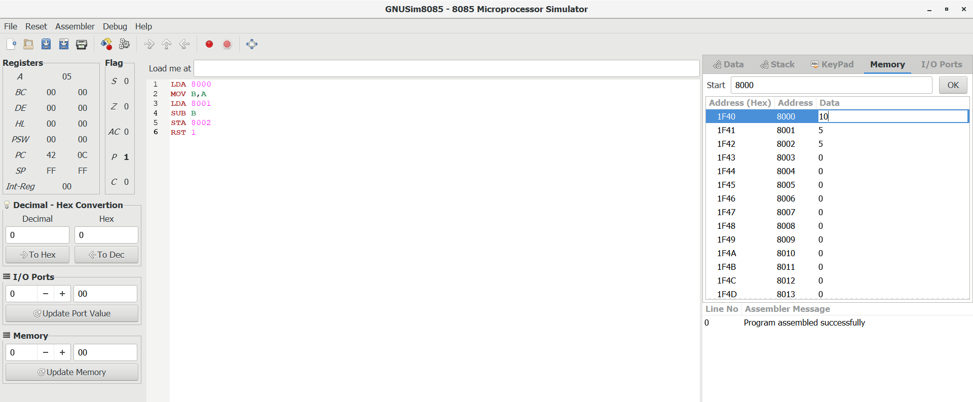

RESULT : Thus the program was executed successfully using 8085 processor simulator